

User Guide

Universal Bank System

Group 4

Software Security

**Index**

|  |  |  |
| --- | --- | --- |
| **S.No** | **Topic** | **Page No.** |
| 1  1.1  1.2  1.3  1.4 | **General Information**  System Overview  Project References  Authorized Use  Point of Contacts | 3 |
| 2  2.1  2.2  2.3  2.4  2.5 | **Getting Started**  Sign up  Logging on  Navigation Menu  Changing user id and password  Exit System | 4 |
| 3  3.1  3.2  3.3 | **Accounts**  Account Credit/Debit  View Statements  Account Transfer | 6 |

**User Guide – Universal Bank**

**1. General Information**

The universal bank system is a bank system that concentrates on the security aspects of banking. It contains all the functionality as described in the Software Requirement Specification.

**1.1 System Overview**

SBS will be developed with a view to provide reliable and secured means of accessing user accounts and performing banking operations in a legal and system allowed fashion. The product is a web based system with a centralized database containing profile and transaction information of all registered users. Functional requirements of the product includes internal transfer of funds from one account of user to another, external transfer from one user account to another user account and payment to merchants through payment gateway. Other functionalities provided by the system will be secured access to user’s own account by external user, approved access to user’s account by bank employees and display and download of transaction statement by user or approved system manager.

**1.2 Project References**

* “Wikipedia”, [*https://www.wikipedia.org/*](https://www.wikipedia.org/)
* “Bootstrap”, [*http://getbootstrap.com/components/*](http://getbootstrap.com/components/)
* “JP Morgan Chase Bank”, [*https://www.chase.com/*](https://www.chase.com/)

**1.3 Authorized Use**

Permission to use this software for any academic purpose with or without fee is hereby granted, provided that the above copyright notice and this permission notice appear in all copies. Any usage of this software that violates academic integrity policies is NOT allowed.

THE SOFTWARE IS PROVIDED "AS IS" AND THE AUTHOR DISCLAIMS ALL WARRANTIES WITH REGARD TO THIS SOFTWARE INCLUDING ALL IMPLIED WARRANTIES OF MERCHANTABILITY AND FITNESS. IN NO EVENT SHALL THE AUTHOR BE LIABLE FOR ANY SPECIAL, DIRECT, INDIRECT, OR CONSEQUENTIAL DAMAGES OR ANY DAMAGES WHATSOEVER RESULTING FROM LOSS OF USE, DATA OR PROFITS, WHETHER IN AN ACTION OF CONTRACT, NEGLIGENCE OR OTHER TORTIOUS ACTION, ARISING OUT OF OR IN CONNECTION WITH THE USE OR PERFORMANCE OF THIS SOFTWARE.

**1.4 Point of Contacts**

* Rajat Aggarwal - rajat.a.aggarwal@asu.edu
* Bharadwaj Aryasomayajula - baryasom@asu.edu
* Kenil Bhatt - kenil.p.bhatt@gmail.com
* Sai Prashanth Chandramouli - Saiprashanth.Chandramouli@asu.edu
* Sai Syama Manojna Kapala - saisyamamanojna.kapala@asu.edu
* Sai Indraneel Patcha - spatcha@asu.edu
* Sidharth Ramesh - sramesh8@asu.edu
* Gaurav Kumar Srivastav - gaurav.srivastav@asu.edu
* Qirui Yang - qirui.yang@asu.eduw

**2 Getting Started**

The following sections outline the basic steps required to get started with the system:

**2.1 Sign up**

In order to signup to the system,

* Click on the Signup link on the navigation bar
* Choose your username and password
* Re-enter the password
* Enter your personal details
* Click Signup when you have entered the details

**Signup**

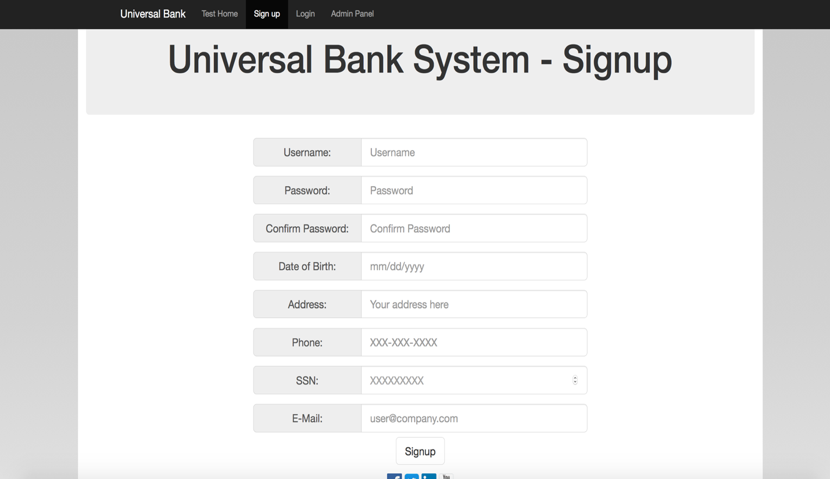

**2.2 Logging on**

In order to log on to the system,

* Click on the Login link on the navigation bar
* Enter your username and password
* Click Login button

**Login Page**

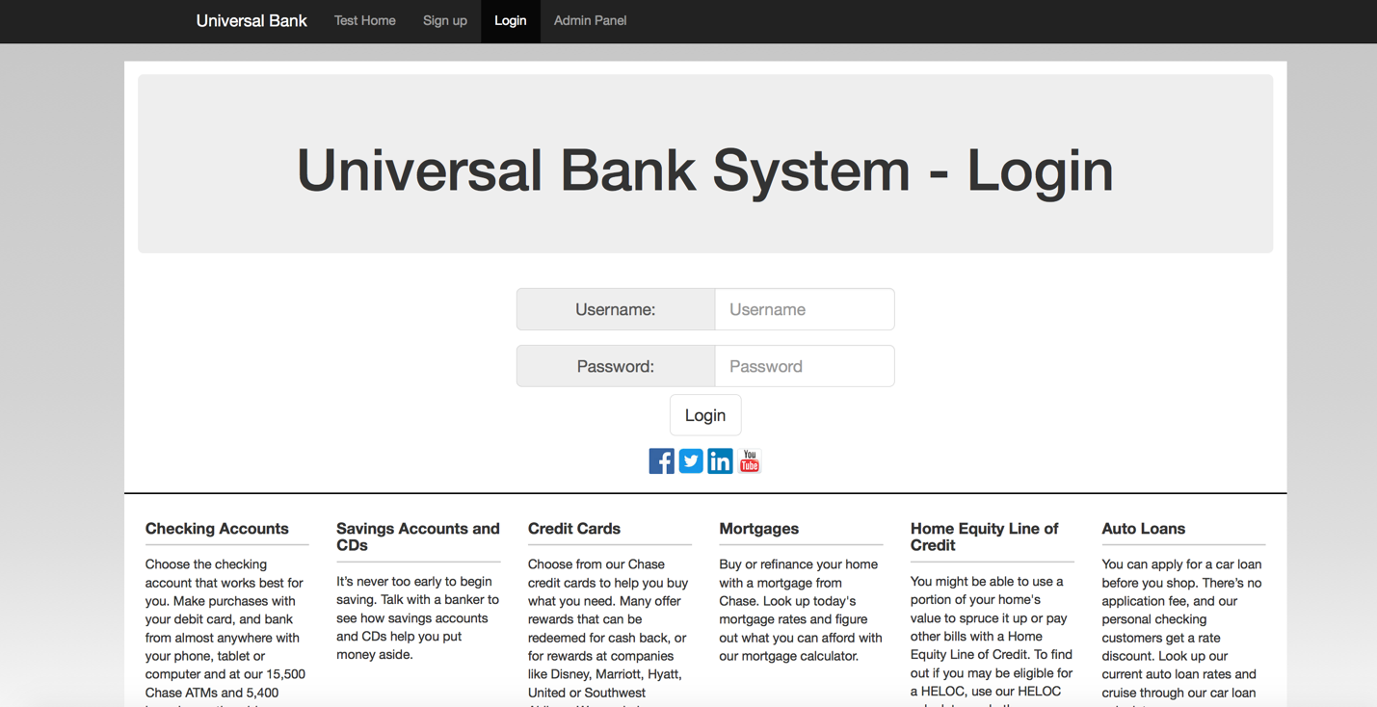

**2.3 Navigation Menu**

The Navigation menu contains four links:

* Home
* Signup
* Login
* Admin Panel

**2.4 Admin Panel**

The admin panel allows an admin of the bank to log in, in order to log in, enter the EmpCode, and the password, and click Submit.

**Admin login Page**

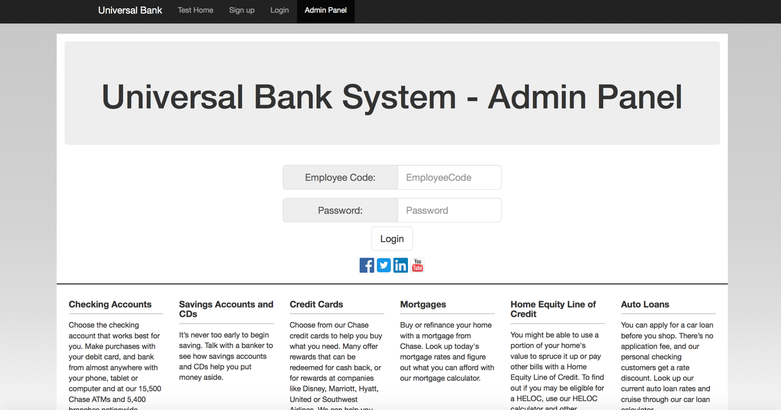

**2.5 Exit System**

In order to exit the system, close the browser.

**3. Accounts**

This section briefly describes the account transactions possible. It assumes that you have already logged into your account.

**3.1 Account Credit/Debit**

In order to credit or debit your accounts, click on the respective links below your account.

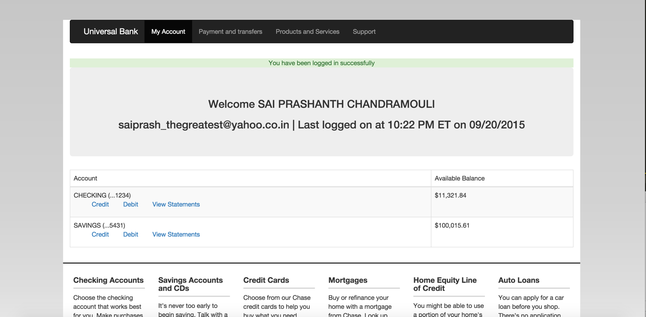

**3.2 View Statements**

In order to view statements for your accounts, click on the `View Statements` link below your account.

**3.3 Account Transfer**

In order to transfer amounts to external accounts from your accounts:

* Click on the `Payments and Transfers` page.
* Select the account from which you want to transfer.
* Fill up the external account details and click Transfer.
 